**Instagram User Analytics Project Report**

Submitted By

Soumyadip Ghosh Date-10/08/2024

*1.Project Description 🡪 So, basically, this project is based on analyzing Instagram users' activity. In this project, I will analyze user activity records/data and, based on the data, I will try to find some insights that will help the organization to make decisions to improve the company's growth.*

*2.Approach 🡪 To implement this project, I followed some steps. First, I checked whether the data is processable or not. Once I confirmed that the data was actionable, I started to study it. After studying the dataset, I checked the the relationships between the different tables in the database. Then, I started thinking about what insights I could retrieve from the data that would help the Marketing Team or Stakeholders to make decisions.*

*3.Tech Stack Used 🡪 In this project, I used MySQL Workbench for managing the relational database and SQL as the scripting language. I have used MySQL Workbench because I am proficient with this Database. And it quite easy and user friendly rather than other Database IDE. Ans it’s provide lots off features that makes my work easy. And SQL is very easy and human being understandable scripting language that’s why I used This.*

*4.Insights 🡪 So, After all study and analyse using my Database Analysis Knowledge I have find out some Insights. So in this Project I have got some Insights where I have did Marketing Analyse and ALSO I tried to find out useful insights which will be beneficial as per Investor’s Metrix.*

*So, The These are the Insight’s and schema model of Database.*

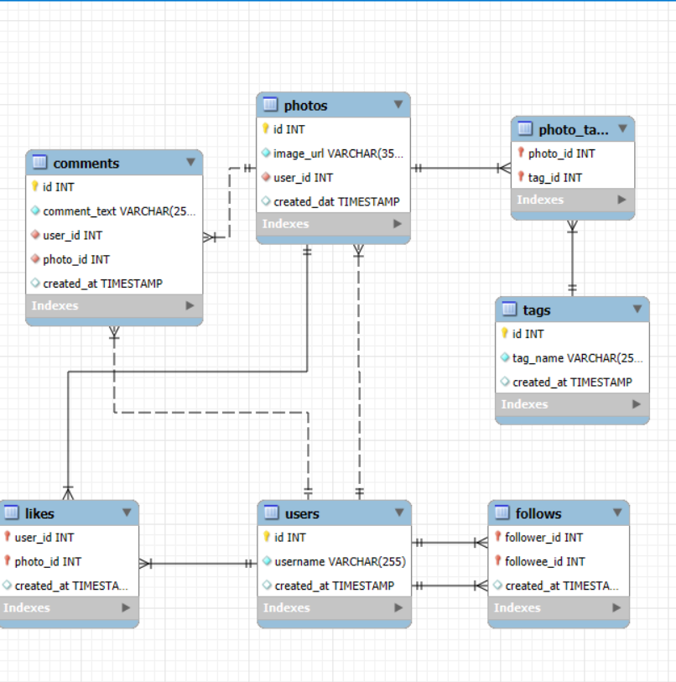

1. ***Loyal User Reward:****The marketing team wants to reward the most loyal users, i.e., those who have been using the platform for the longest time.*

*So I find out 5 oldest user’s of Instagram as per the DATASET.*

*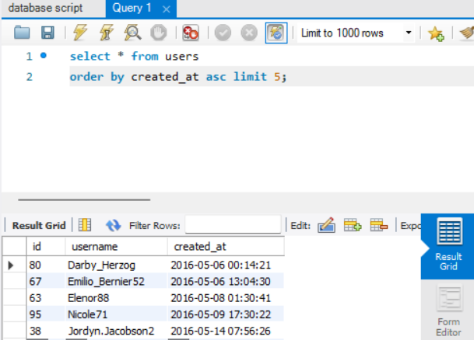;*

***select * from users***

***order by created_at asc limit 5;***

1. ***Inactive User Engagement:****The team wants to encourage inactive users to start posting by sending them promotional emails.*

*So I find the user’s who didn’t posted a single photo.*

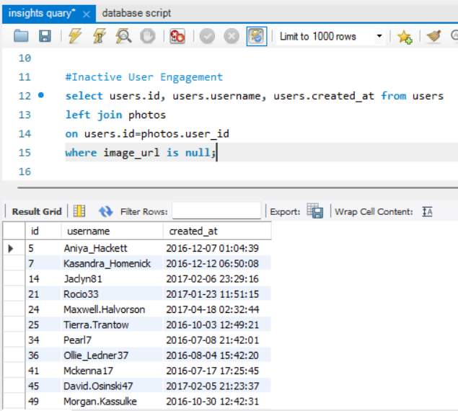

*\*\*\* There is some data which is not in this iamge.\*\*\**

***Select users.id, users.username, users.created_at from users***

***left join photos***

***on users.id=photos.user_id***

***where image_url is null;***

1. ***Contest Winner Declaration:****The team has organized a contest where the user with the most likes on a single photo wins.*

*So, I find out the 3 photo’s and the user details of the photo , in which photo audience are liked most.*

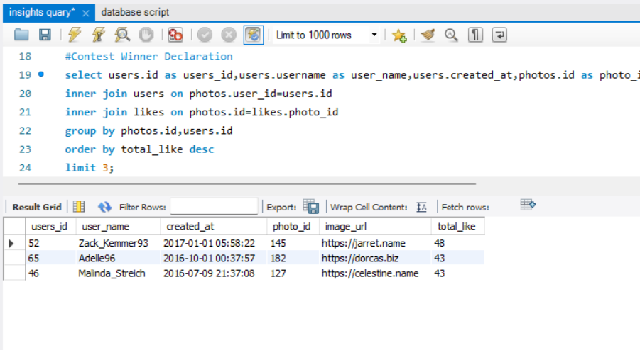

***select users.id as users_id,users.username as user_name,users.created_at,photos.id as photo_id,photos.image_url,count(likes.photo_id) as total_like from photos***

***inner join users on photos.user_id=users.id***

***inner join likes on photos.id=likes.photo_id***

***group by photos.id,users.id***

***order by total_like desc***

***limit 3;***

1. ***Hashtag Research:****A partner brand wants to know the most popular hashtags to use in their posts to reach the most people.*

*Now I find the 5 most popular Tags.*

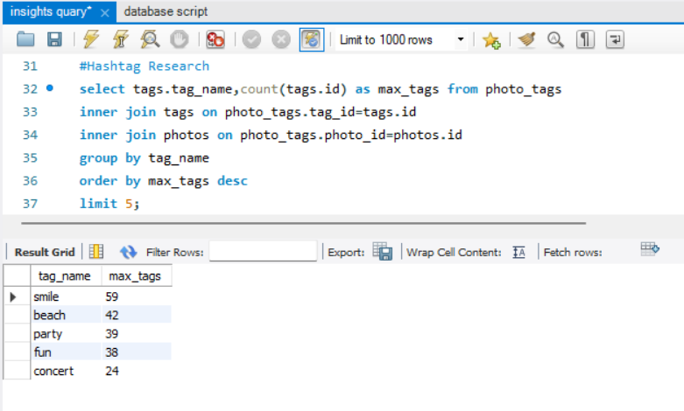

***select tags.tag_name,count(tags.id) as max_tags from photo_tags***

***inner join tags on photo_tags.tag_id=tags.id***

***inner join photos on photo_tags.photo_id=photos.id***

***group by tag_name***

***order by max_tags desc***

***limit 5;***

1. ***Ad Campaign Launch:****The team wants to know the best day of the week to launch ads.*

*So ,I find out , in which day of a week most user are doing registration in Instagram.*

*\*\*\*And after Deep Analysis I find That , in Thursday and Sunday max user’s are doing registration and at the time between 19 p.m. to 20 p.m. of Sunday the no of registration is maximum.\*\*\**

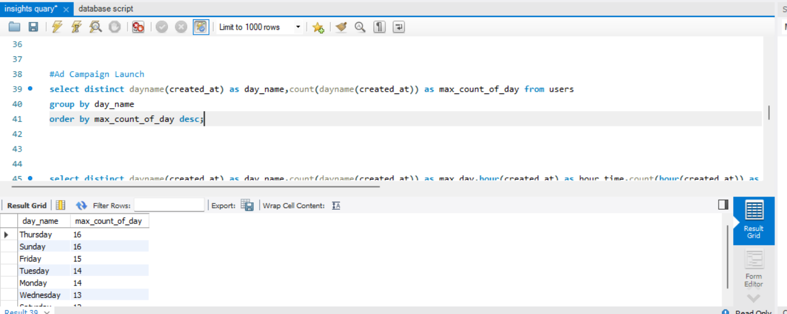

***select distinct dayname(created_at) as day_name,count(dayname(created_at)) as max_count_of_day from users***

***group by day_name***

***order by max_count_of_day desc;***

1. ***User Engagement:****Investors want to know if users are still active and posting on Instagram or if they are making fewer posts.*

*So, Here I calculated*

1. *the average number of posts per user on Instagram(In the case ,where many user posted photo multiple times)*
2. *the total number of photos on Instagram divided by the total number of users*

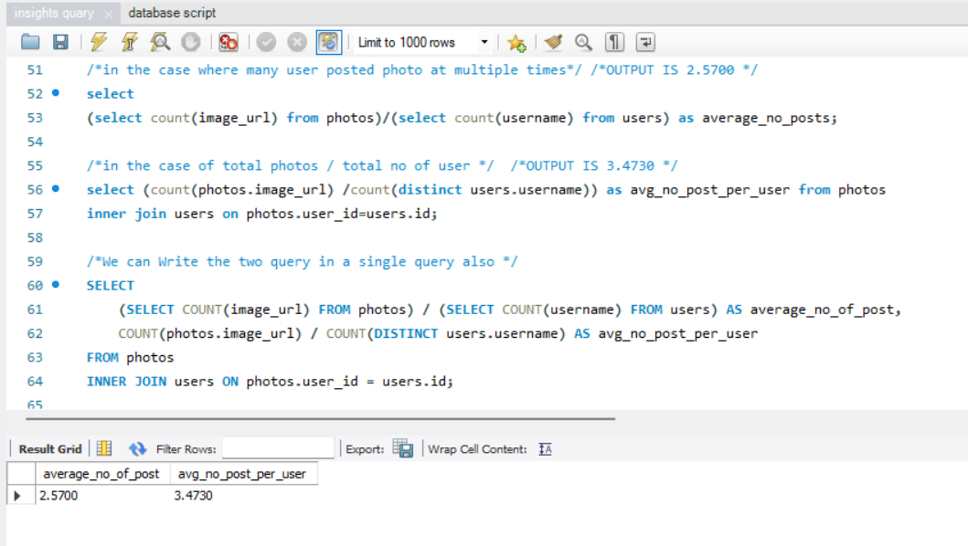

***/*in the case where many user posted photo at multiple times*/ /*OUTPUT IS 2.5700 */***

***select***

***(select count(image_url) from photos)/(select count(username) from users) as average_no_posts;***

***/*in the case of total photos / total no of user */ /*OUTPUT IS 3.4730 */***

***select (count(photos.image_url) /count(distinct users.username)) as avg_no_post_per_user from photos***

***inner join users on photos.user_id=users.id;***

***/*We can Write the two query in a single query also */***

***SELECT***

***(SELECT COUNT(image_url) FROM photos) / (SELECT COUNT(username) FROM users) AS average_no_of_post,***

***COUNT(photos.image_url) / COUNT(DISTINCT users.username) AS avg_no_post_per_user***

***FROM photos***

***INNER JOIN users ON photos.user_id = users.id;***

1. ***Bots & Fake Accounts:****Investors want to know if the platform is crowded with fake and dummy accounts.*

*So,to know this I extracted the user who are liked in all posts.*

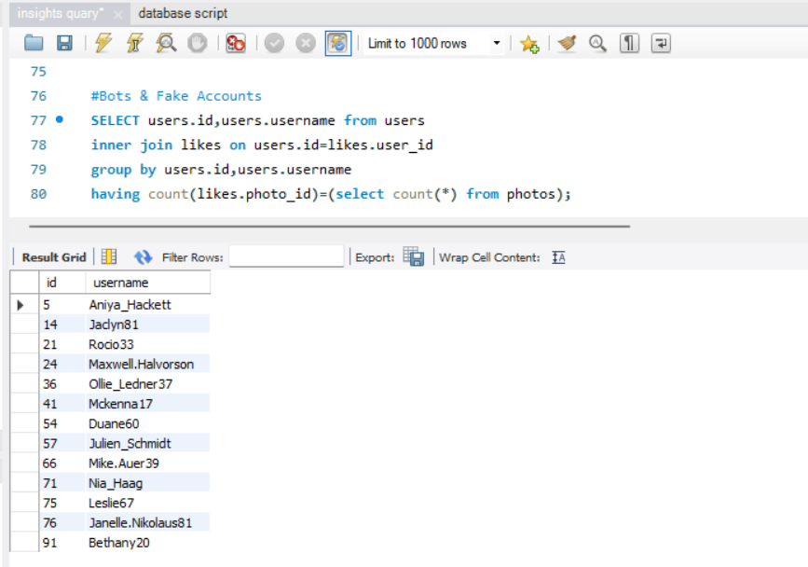

***SELECT users.id,users.username from users***

***inner join likes on users.id=likes.user_id***

***group by users.id,users.username***

***having count(likes.photo_id)=(select count(*) from photos);***

***/\**** *Along with This all I also find out the users who are posted photos multiple times*/*

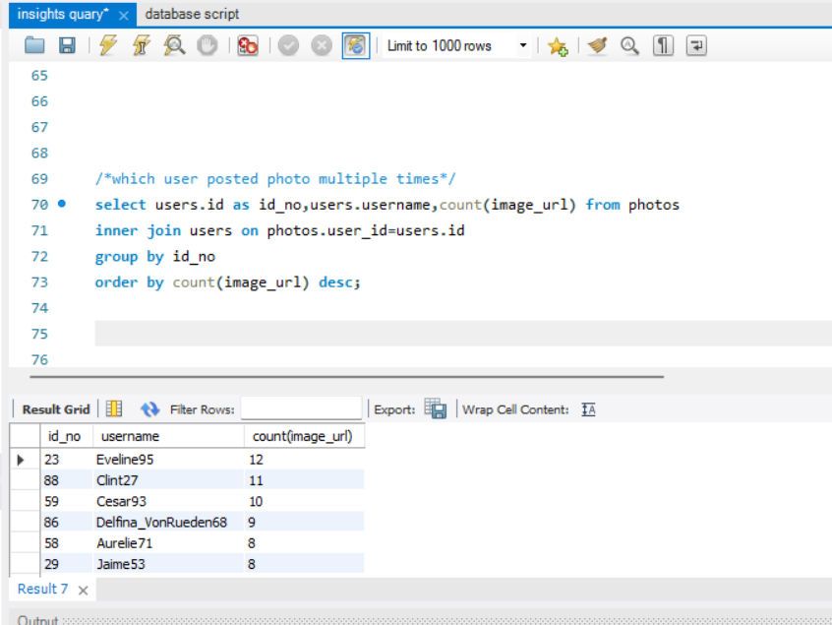

***select users.id as id_no,users.username,count(image_url) from photos***

***inner join users on photos.user_id=users.id***

***group by id_no***

***order by count(image_url) desc;***

*5.Results 🡪 So, I have gained practical knowledge of Data Analysis. Also, I learned work flow of Data Analytics. I understand that Business understanding is also very important for Data Analysis and realized that playing with Data is not too easy we have to understand the Data first very well, after that we will be able to get some important insights from our Data. After doing this project I have improved my showcasing skill also.*

*So, I have find out the above insights which will be help to take decision and grow the business in this competitive market.*